Do You Know How Much Your Home is Really Worth?
To:
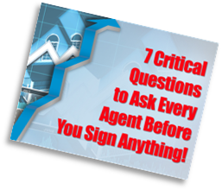
If You’re Planning On Selling Your Home In The Next 12 Months...
Don’t Sign Anything Until You Get
“7 Critical Questions to Ask
Every Agent Before You
Sign Anything”.
This Powerful Booklet is FREE of Charge and There is No Obligation. Simply go to:
http://ListingInfoDirect.com

Beat
Other
Home
Buyers
to the
Punch…
To:
Get a List of EVERY Home in Every Area of Interest Instantly With New Home Buyer Service…
Our NEW Home Finder Service Will Send You Details on Every Home in Every Area Matching Your Home Buying Criteria Instantly. The Service is FREE and there is No Obligation.

ListingInfoDirect.com
Beat other Home Buyers to the punch with this valuable FREE Service. It’s the unfair advantage to finding your next home!

New FREE
Service
Makes
it Easy to
Find the
“Best Home
Buys In
Riverside
County?
To:
New Consumer Service Voted Fastest Way to Find The Best Home Buys in Riverside County…

That’s right; this new FREE consumer service provides you a weekly list of the areas Hottest Home Buys delivered to your email in-basket. Go to:
Top5HomeBuys.com
No Hassles. No Obligation.

Don’t Give Your Home Away, Find Out What It’s Really Worth With New FREE Service…
Get a FREE, no obligation, current Market Valuation on your home WITHOUT having to go through a real estate agent or pay someone else to do it. Go to:

http://MarketValueDirect.com

Learn the truth about your home’s current market value BEFORE you sign anything or give it away.
It may surprise…even shock you.
Don’t Give Your Home Away in
This
RED-HOT Market!
To:

